Result Screenshots
Step 1: POST - Create a New Loan
JSON
{
"borrowerName": "John Doe",
"amount": 5000.00,
"loanTermMonths": 24,
"isApproved": false
}
Screenshot 1 Requirement: Show a 201 Created status code and the returned JSON object with an assigned Id.
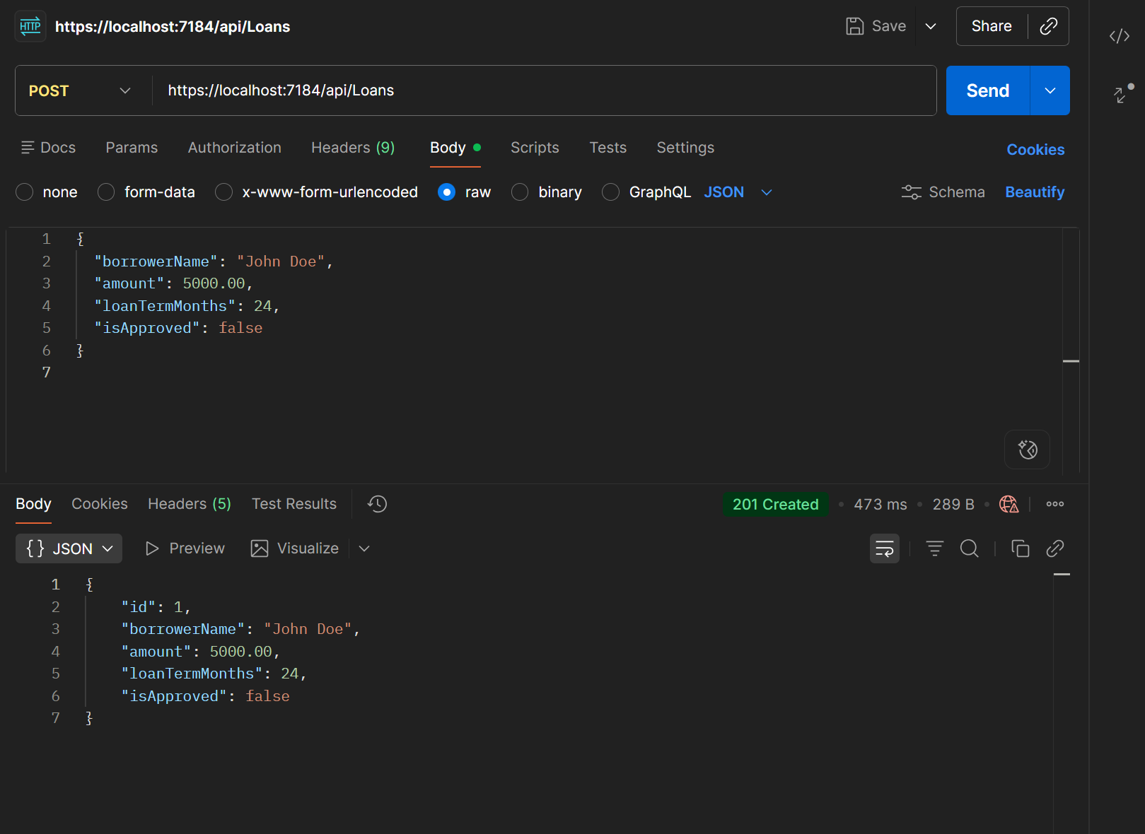

Step 2: GET - Retrieve All Loans
Screenshot 2 Requirement: Show the list of loans in the response body with a 200 OK status.
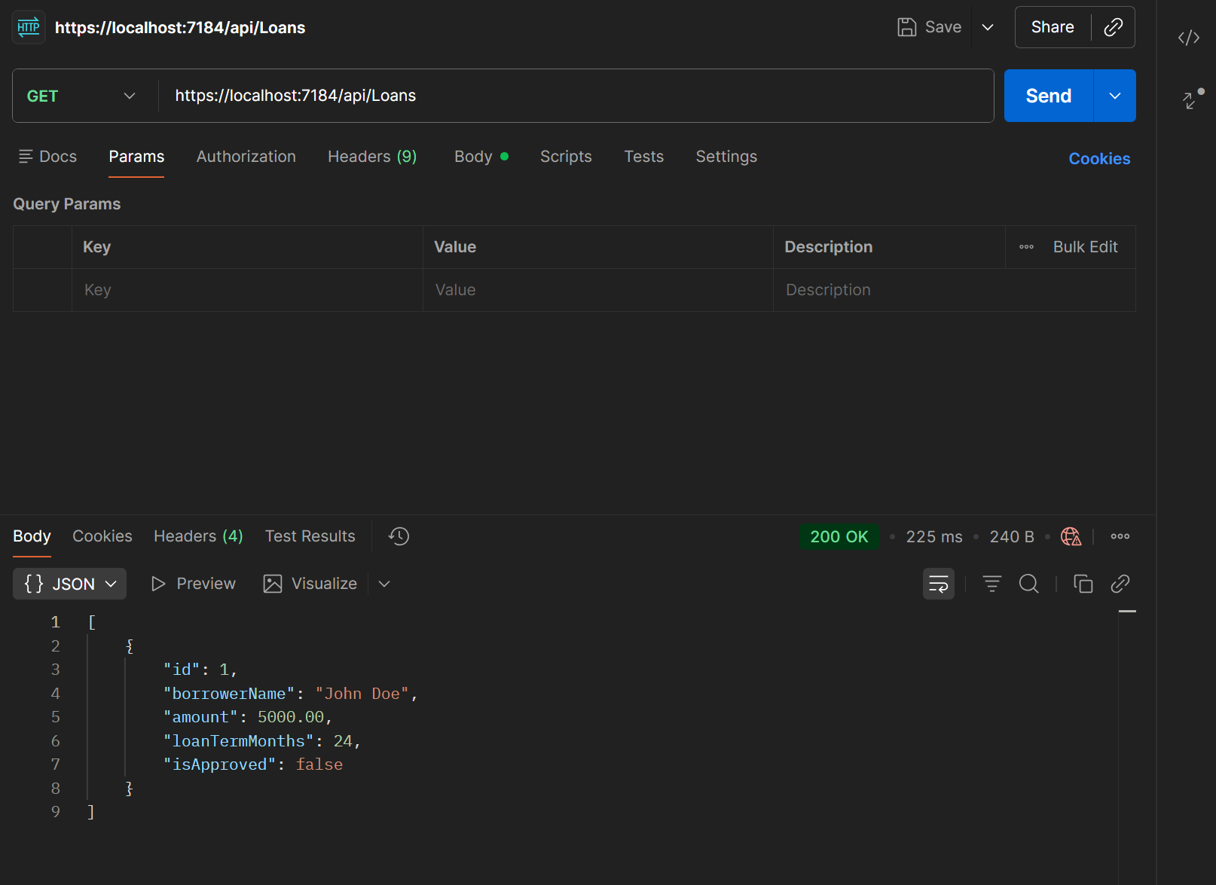

Step 3: PUT - Update (Approve) a Loan
JSON
{
"id": 1,
"borrowerName": "John Doe",
"amount": 5000.00,
"loanTermMonths": 24,
"isApproved": true
}
Screenshot 3 Requirement: Show a 204 No Content (or 200 OK) status, proving the update was successful.
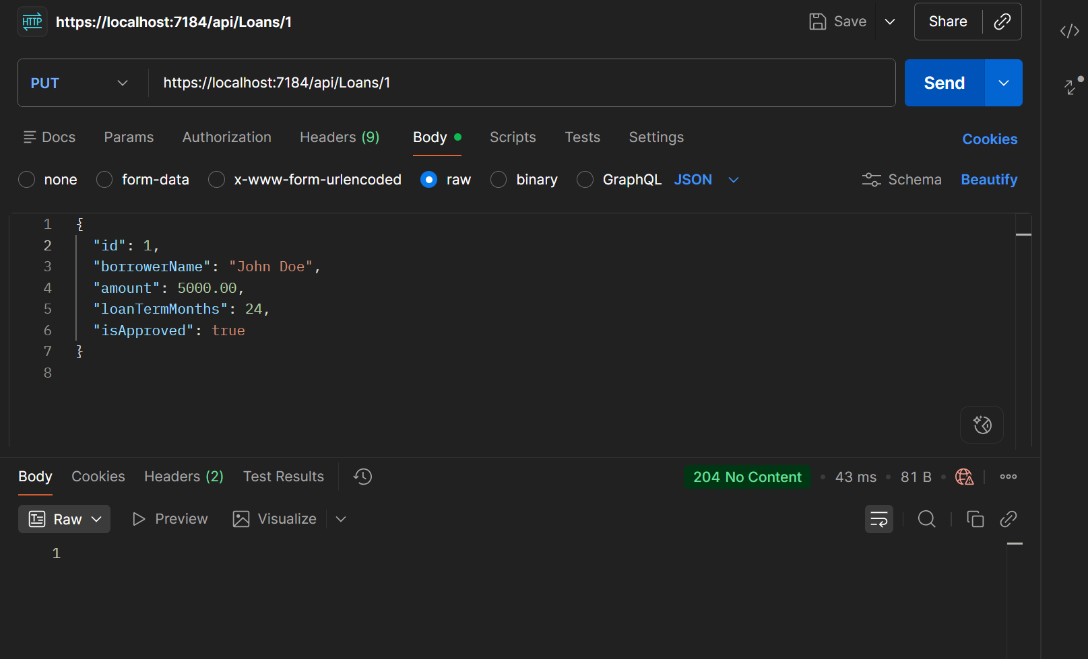

Step 4: DELETE - Remove a Loan
Screenshot 4 Requirement: Show a 204 No Content status. Follow this up with a GET request showing a 404 Not Found to prove it's gone.
